What is behave?
- Behave is behavior-driven development designed for Python
- It is an agile software development technique that encourages collaboration between developers, QA and non-technical or business participants in a software project.
- Behave operates on directories containing:
  - Feature files written by your Business Analysts/Sponsor/Whoever with your behavior scenarios in it and
  - A step directory with python step implementation for the scenarios
BDD Scenarios and Feature Files in Gherkin:
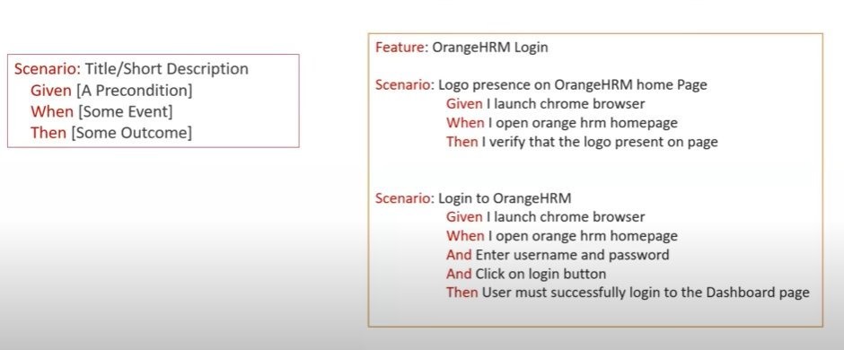
Official WebSite: https://behave.readthedocs.io/en/latest/tutorial/
Environment Setup:
- Install Python
- Pycharm IDE
- Selenium library
- Behave
Python Behave with Selenium:
- Project Creation
- First Selenium Test
- Install selenium package
- Install behave package
- Selenium – Drivers for browser
https://www.selenium.dev/downloads/
- Goto Settings -> plugins -> marketplace -> search Gherkin plugin and get installed.
- Step parameters
- Scenario outline
- Background:
In Behave BDD, the Background keyword is used to define a set of common steps that are executed before each scenario within a feature file. This mechanism helps to reduce redundancy and improve the readability and maintainability of your feature files.
- Allure reports
  - Prerequisites: allure-behave
  - cmd: pip install allure-behave /pip uninstall allure-behave
  - terminal of pycharm: behave ./features
  - install allure package in pycharm
  - goto new project settings -> settings for new projects -> python interpreter -> install allure-behave package
  - Goto terminal -> type command:
behave -f allure_behave.formatter:AllureFormatter -o allure-results
Download allure: https://github.com/allure-framework/allure2/releases
Add bin path of it to the environment variables.
  - Terminal -> cmd -> allure generate allure-results -o allure-report
- Page Object Model:
Website: tutorialninja.com/demo/

- POM is a design pattern in test automation that promotes modularity, reusability, and maintainability by separating the UI logic (page structure) from the test logic (steps and assertions).
Key Components in POM with Behave:
1. Feature Files (.feature)
- Written in Gherkin syntax.
- Describe test scenarios in a human-readable format.
2. Step Definitions (steps/*.py)
  - Python functions that map to Gherkin steps.
  - Use @given, @when, @then decorators from behave.
3. Page Objects (pages/*.py)
- Python classes that represent web pages.
- Contain locators and methods to interact with elements.

4. Environment Hooks (environment.py)
- Setup and teardown logic for scenarios.
- Commonly used to initialize and quit the WebDriver.

Benefits of POM:
Separation of concerns | Keeps test logic and UI logic separate
Reusability | Page methods can be reused across scenarios
Maintainability | Changes in UI require updates only in page classes
Readability | Gherkin + POM makes tests easy to read and understand

